Name : Hamna Sarfraz

Lab Assignment

Title:
Installation of Kali Linux on VirtualBox

Objective:
To install and run Kali Linux on a virtual machine for cybersecurity practice.

Requirements:
- VirtualBox
- Kali Linux Image
- 4 GB RAM
- Internet Connection

Steps:

Step 1: Download Kali Linux
- Go to official Kali Linux website
- Download VirtualBox image
Screenshot:
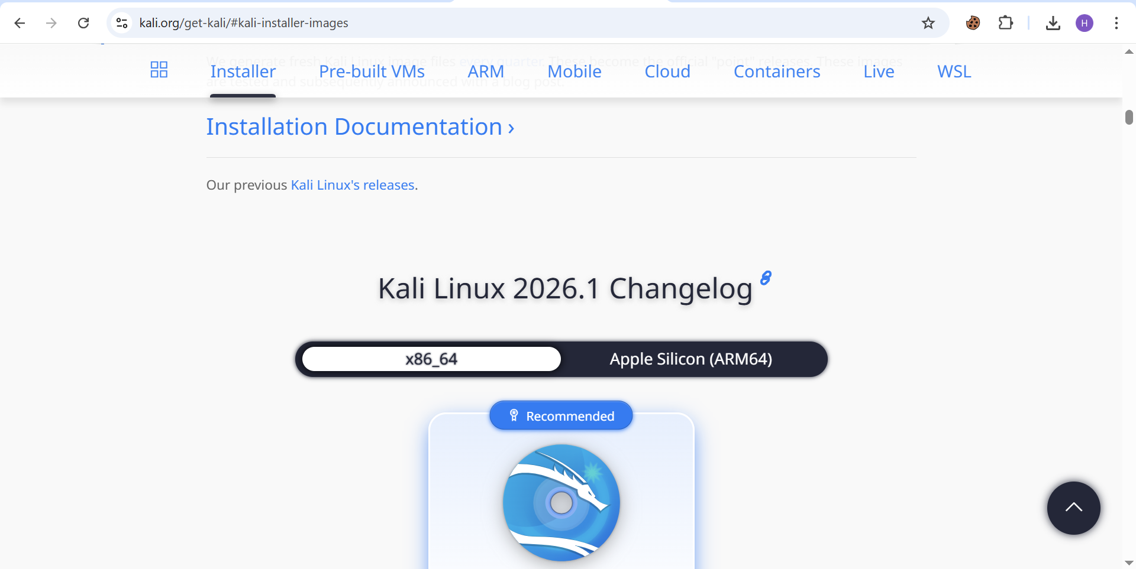

Step 2: Install VirtualBox
- Download and install VirtualBox
- Follow Next → Next → Install
Screenshot:
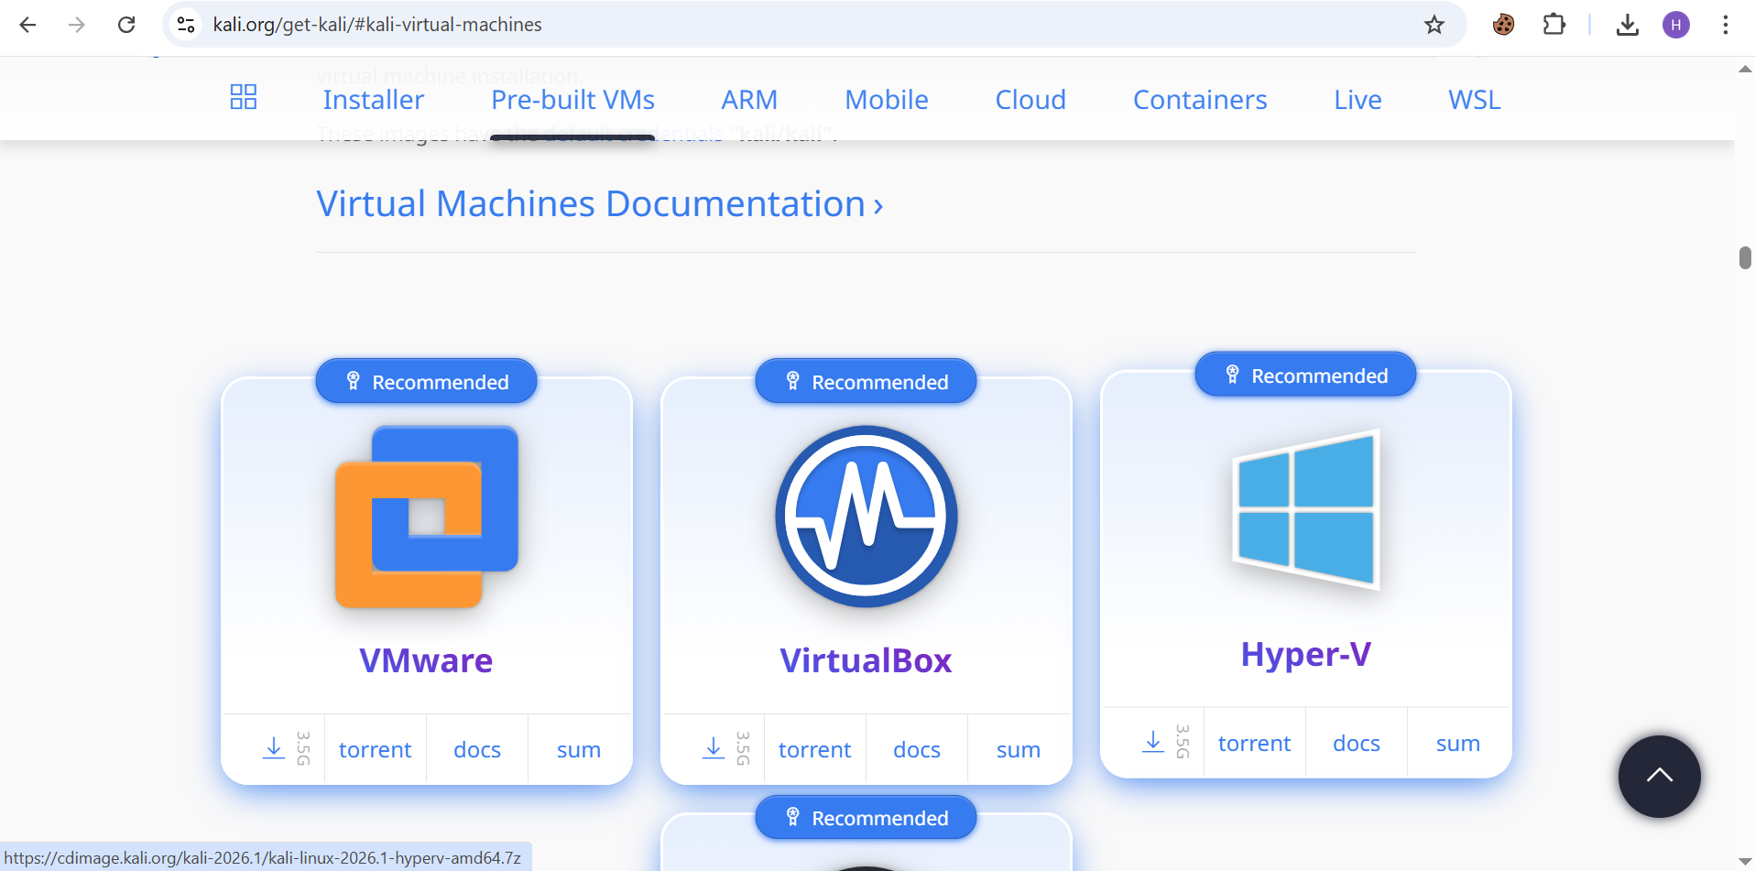

Step 3: Import Kali Linux
- Open VirtualBox
- Click File → Import Appliance
- Select Kali Linux file
Screenshot:
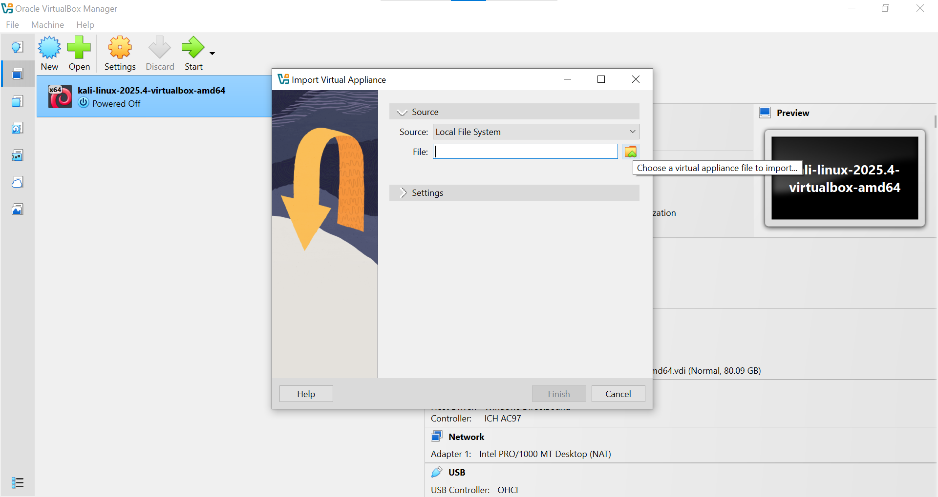

Step 4: Start Kali Linux
- Click Start
- Login using:
  - Username: kali
  - Password: kali
Screenshot:


Result:
Kali Linux was successfully installed and is ready to use

